**Dependency Injection**

Dependency or dependent means relying on something for support. Like if I say we are relying too much on mobile phones than it means we are dependent on them.

When class A uses some functionality of class B, then its said that class A has a dependency of class B.

**So, transferring the task of creating the object to someone else and directly using the dependency is called dependency injection.**

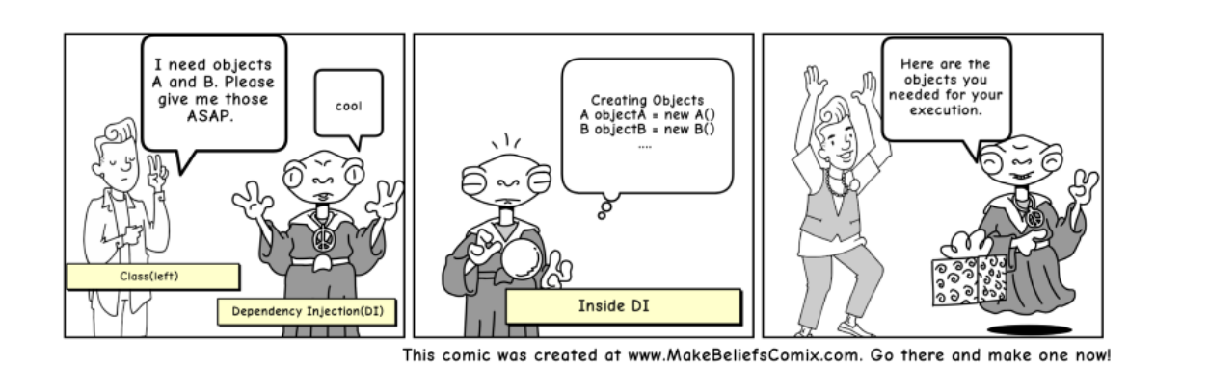

In programming suppose we have twenty classes and they are required to use a method from one class. So each class can instantiate the required class. Let one class that is providing method is changed and that class exactly the provide same method with different logic so we have to use that method for that we have to provide that class instead of old one now we have to replace name in each class.

So to overcome that we can create dependency injection in class constructor and provide the class instance to it. So we can instantiate that class once and then provide its object to all place where we use twenty classes.

**1 Decoupling**

A service is nothing more than a PHP Object that can perform a certain (global) task. These services can be injected into other services without being dependent on each other.Their purpose is isolated and can easily be swapped out by other components later. This way your code will be cleaner and decoupled. In my Computer example, it means that injecting a different hard drive or making changes to the original hard drive should not make the computer crash.

**2 Reusable code**

Another advantage of dependency injection is that your code will be more reusable since there are no direct dependencies on other entities (objects or classes) in your code.

**3 Testable code**

Your code becomes easier to test when you use dependency injection. Dependencies can be injected and therefore, be replaced by mock implementations that can be configured.